**SYSTEM INSTALLATION MANUAL**

This section gives an overview of the system. It consists of Installation and Configuration Software and Hardware Requirements.

**1.1 System Requirements**

Hardware Requirements

Processor Intel Core i3 or higher recommended

Memory 4 GB RAM or more recommended

for database or combined web

/database server

HDD Free Disk Space: 4 GB

CPU Quad 4GHz+ CPU

Network Up to 3 Mbps internet connection or higher recommended

Processor Type 32 bit

Processor Speed 2.97GHz or higher recommended

OS Any Linux distro, Windows, MAC

Software Requirements

PHP Greater than or equal to version

5.6.4

Web Server Apache 2.4

MySQL Greater than or equal to version

5.6

OS any Linux distro, any Windows, MAC

**1.2. Installation/Deployment**

To Deploy HATOD Tracking System from the CD:

* Sign up at CloudWays and Login to your Account.
* Register and Log-in to GitHub.

1. In the Platform dashboard of GitHub click the applications tab from the menu bar and select application.

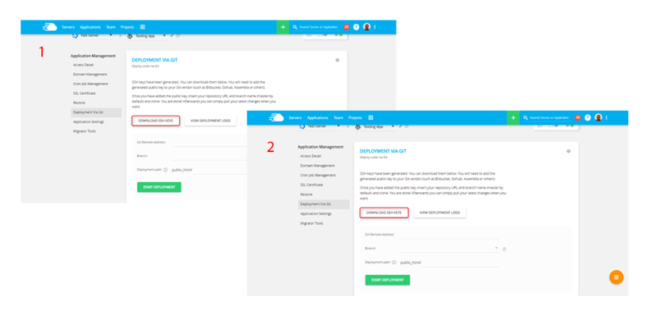2. For SSH key click ' DEPLOYMENT VIA GIT' button on 'APPLICATION MANAGEMENT' area and then click the ‘GENERATE SSH KEYS’ button to generate SSH key. To Download keys, click ‘DOWNLOAD SSH KEYS’.

3 .Upload the ‘SSH PUBLIC KEY’ to your GitHub account. In order to do this, login to your GitHub account, go to the desired repository, and then into the ‘SETTINGS’ tab. Click the ‘ADD DEPLOY KEY’ button and add the Public SSH Key which you have downloaded from CloudWays platform. Click ‘ADD KEY’ button to finalize the process.

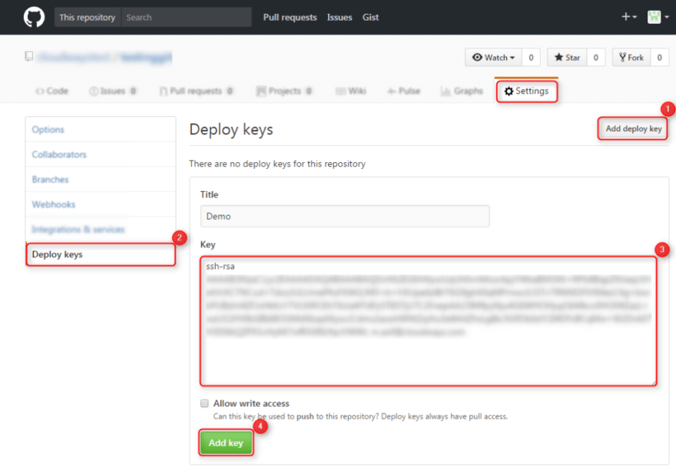

4. Now copy the Repository SSH Address that you will see in the top panel in your main GitHub dashboard. Copy and paste this address in your CloudWays’ ‘GIT REMOTE ADDRESS’ field.

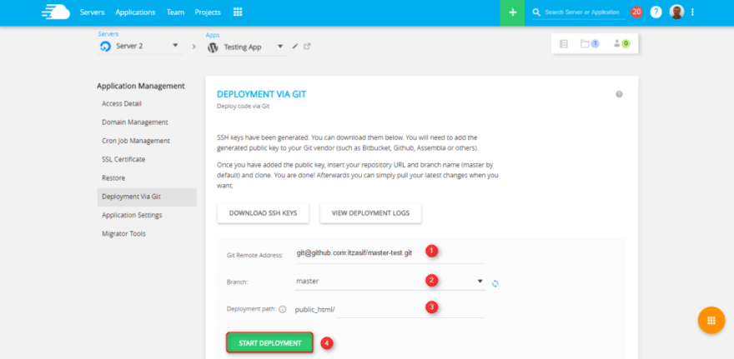

5. Lastly, input the deployment path and click on ‘START DEPLOYMENT’ button to have your application code deployed onto the CloudWays platform.